|  |  |
| --- | --- |
| Course Name | ITD 2313 – Script Programming |
| Instructor | Mark Pranger |
| Student Name | Josh Jones |
| Due date | May 26 |
| Grade | <grade earned here> |
| Grading Comments | <instructor comments here> |

Page 65:

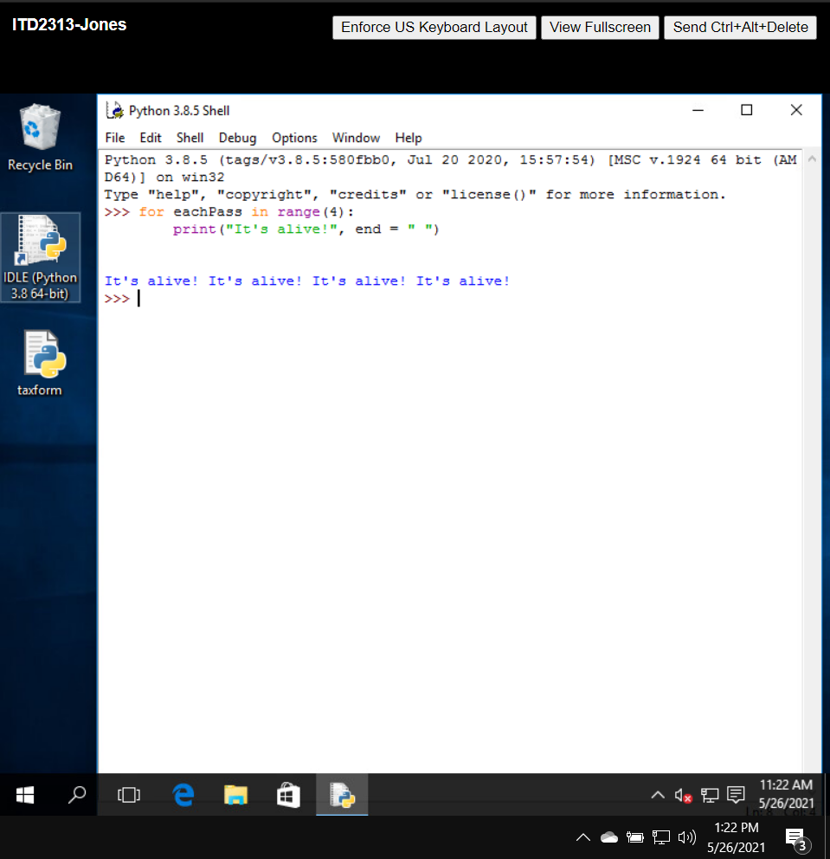

Page 66:

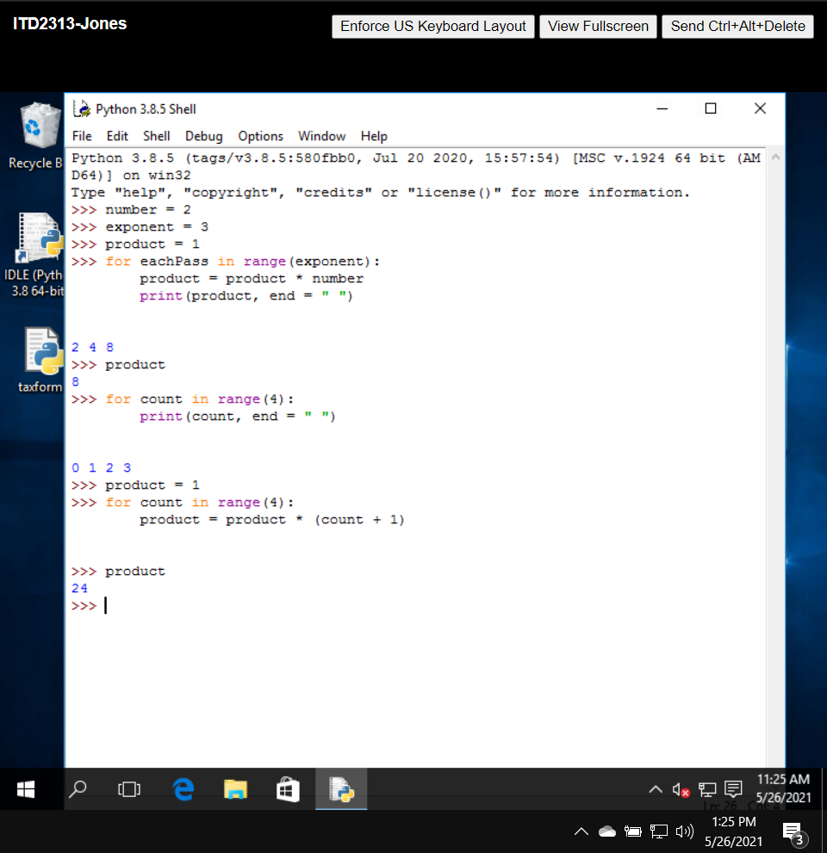

Page 67:

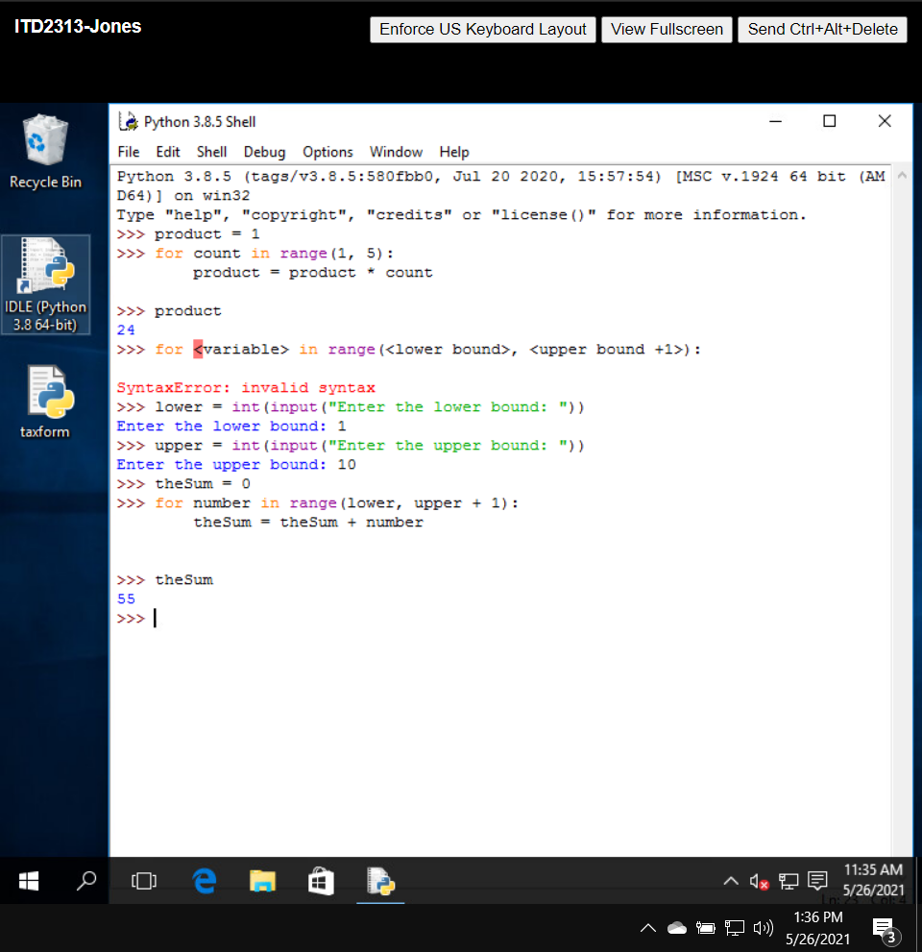

Page 68:

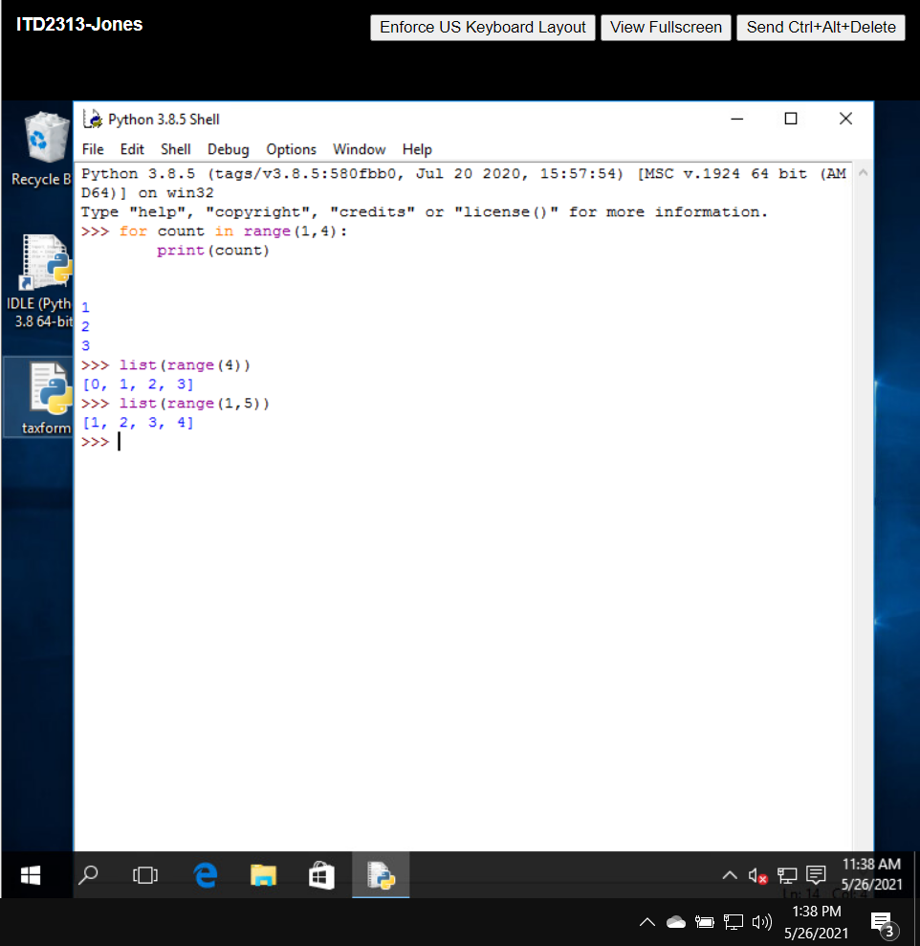

Page 69:

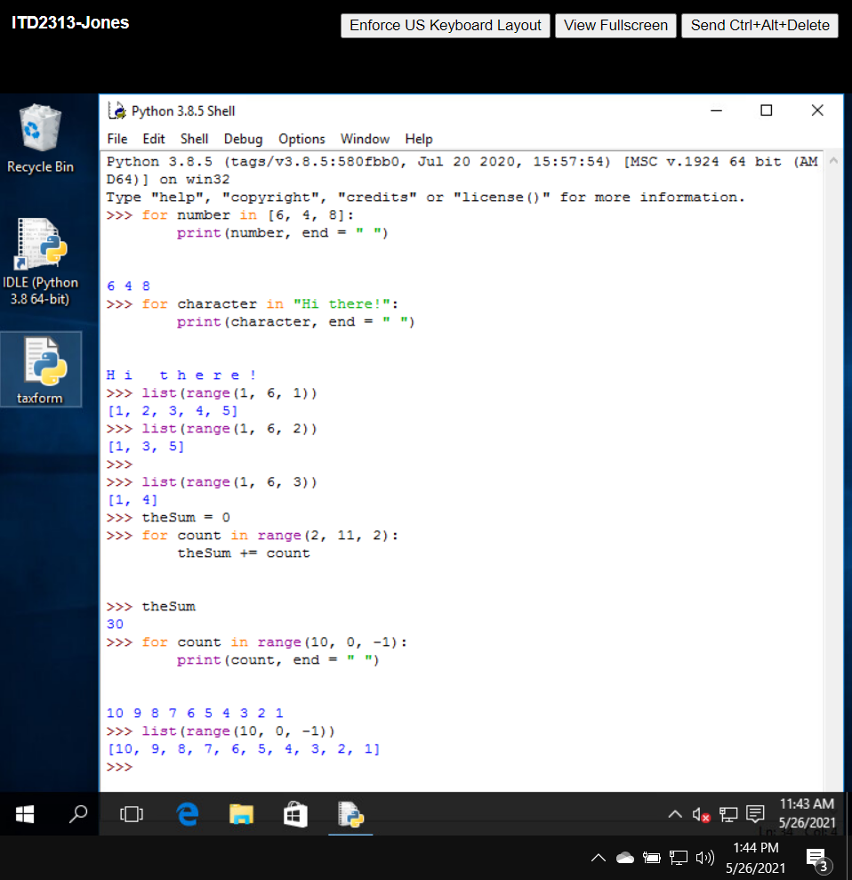

Page 71:

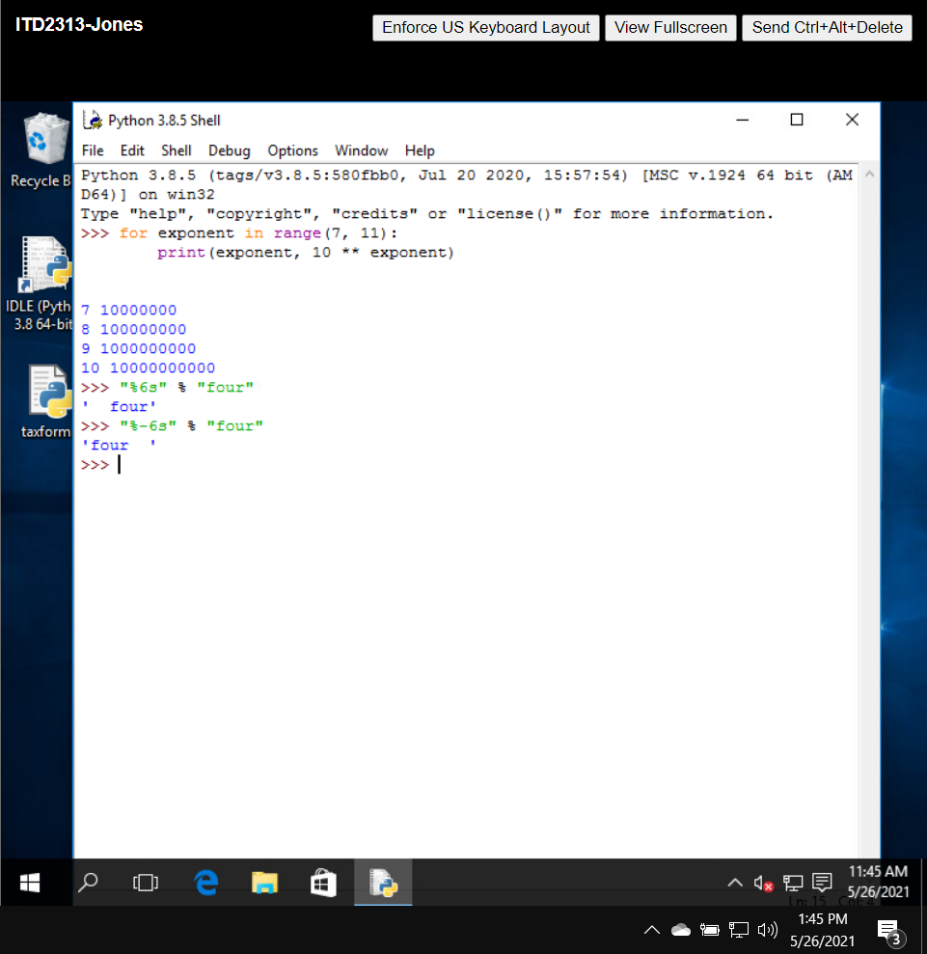

Page 72:

